READ ME!
By Jeanie Chan (jaceycori@gmail.com), M.A.Sc., Sept. 2009-Sept. 2011.

Table of Contents
General 2
Brian’s Speech Synthesizer 2
Required software 2
Setup 2
Brian’s Jaw Motors 2
Brian’s Body Servo Motors 2
Description: 2
How to configure 2
Speech Recognition & Analysis 3
Required Software 3
Configuration and Execution 3
Description of Programs 4
Inter-module Communication 4
Meal-time Scenario 5
To Run: 5
Hardware 5
Controller 5
Program Organization 5
Important Files 5
User State Detection 5
Required Software 6
Autosmiley 6
Facetracker 6
Utensil Tracking (adib.saad@utoronto.ca) 6
Software Required 6
Calibration 6
Troubleshooting 7
Meal Tray (amy.do@utoronto.ca) 7
Change Empty Dishware Weights 7
Calibration Steps for the Mirco Load Cells (0.78 g): 7
Memory Game 10
To Run: 10
Hardware 10
Robot-MAXQ 10
Program Organization 10
Important Files 10
Colour-based Method for Card Detection 10
Required software 11
Changing Colour Ranges 11
Heart-rate Monitoring 11
Required Software 11
Troubleshooting 11
SIFT-based Method for Card Detection 11
Execution 11
Important Folders 11
Voice Intonation 11
Required Software 11
Important Files 12
Bijan’s Notes (bijan.shahriari@utoronto.ca) 12

General
These are programs that used by both Scenarios.

Brian’s Speech Synthesizer

Required software
- “NeoSpeech Paul” voice

Setup
- Install Hal TTS
- Put the “verification.txt” file in this folder: C:\Program Files\Zabaware\HalReader\Paul\data-common\verify. This file should be on the laptop in the same folder.
- The app “TTSApp.exe” which is in C:\Program Files\Zabaware\HalReader\Paul\lib is useful when you just want to make the robot say something without coding it.

Brian’s Jaw Motors
- You need split the speaker output with a cable and connect one of them to the Jaw servo control board, which is powered individually (not with batteries like the body). Turn the volume on your computer to max.

Brian’s Body Servo Motors
- Output signals from the computer to the SSC-32 Servo Controller through a serial port is done using C++ with the CSerial Library found at: http://www.codeproject.com/KB/system/serial.aspx
- Information and manuals for the SSC-32 Servo Controller may be found here: http://www.lynxmotion.com/Product.aspx?productID=395
- LynxTerm, a program used for testing the servo controller may be found at: http://www.lynxmotion.com/Product.aspx?productID=567&CategoryID=15#downloads

Description:
Since the majority of the programs for the experiment were written in C++, it made sense to have serial output signals written in C++ as well. We used the libraries written by Ramon de Klein to control our servo outputs. The SSC-32 board moves whenever there is a valid string of text that specifies the channel to move, the resulting location, and the amount of time to reach the specified location. To move the servos using C++, a string was sent to the servo controller.

How to configure
- For successful serial communication, it needs to be properly set up. To open the port, use the command: serial.Open(_T("COM6")); Note: See the computer device manager to find out which COM port the robot is connected to. It may not be COM6.
- This opens up the com port #6. Be sure that the port number is one digit as the library is not programmed to accept two digits. After opening the port, set it up using: serial.Setup(CSerial::EBaud9600,CSerial::EData8,CSerial::EParNone,CSerial::EStop1);
- The arguments above sets up (in the order they appear) the baud rate, data bits, parity, and stop bits.
- In order to move the servos, a string can be sent to the controller by using the command: “serial.Write”. The string sent should be in the format of: serial.Write("#X PXXX TXXX\r");
- The first part (after the #) is the servo channel, the second (after the P) is the final position, and the third (after the T) is the amount of time (in milliseconds) taken to move to that position. Always end the string in “\r” so the command is sent to the controller. It is also possible to control more than one servo in one line of command. An example would be: serial.Write("#9 P2250 #10 P750 T4000\r");
- This code moves the servo on channel 9 to position 2250 and servo 10 to position 750 in 4 seconds.
- More commands are available for the servo controller in the SSC-32 Users Manual found on their site.
- You should test the positions of the servos by using LynxTerm before actually using them in C++ because values outside the servo range may burn the motor.

Speech Recognition & Analysis
Folders:
- julius-4.1.5
- Speech Analysis

Required Software
- ActivePerl (http://www.activestate.com/activeperl)

Configuration and Execution

julius-4.1.5
This is the folder containing the source code and binaries of the speech recognition engine that was used. The primary work folder was julius-4.1.5/msvc, which contains all the files needed to run the engine. The configuration file is used to indicate the grammar, vocabulary, and acoustic models to be used. The current configuration file is julian.conf in the julius-4.1.5\msvc folder. A copy of runJulius.bat and julian.jconf are also included in this folder. To use the speech recognition engine, run runJulius.bat.

SpeechAnalysis
This is the folder containing the source code and binaries of the speech analyzer. This program can be run by simply opening SpeechAnalysis.exe, with no command line parameters.

Language Model
- The grammar files are stored in \julius-4.1.5\msvc\grammar. A large repository of words is found under the folder julius-4.1.5\msvc\acoustic_model_files\dict. These words can be added to the current grammar files to expand the vocabulary.
- To modify the grammar and vocabulary detected, change the .voca and .grammar files:
  - Install ActivePerl (http://www.activestate.com/activeperl)
  - Copy the mkdfa folder in julius-4.1.5\gramtools\ into the C:\
  - Copy .voca and .grammar files from \julius-4.1.5\msvc\grammar into the new mkdfa folder
  - Change the .voca and .grammar files as desired.
  - From the command prompt, navigate to the new mkdfa folder
  - Type mkdfa.pl [name of .voca and .grammar file]. (e.g. mkdfa.pl test)
  - Copy the new .voca, .term, .grammar, .dict, and .dfa files back to \julius-4.1.5\msvc\grammar
- Detailed information on how to add grammar and vocabulary can be found here: http://julius.sourceforge.jp/en_index.php?q=en_grammar.html

Acoustic Model
The acoustic model used is the Voxforge open-source model that can be downloaded from their site: http://www.voxforge.org/. It is recommended to download the latest nightly build, since the one included in this project is from August 2010. Put new acoustic model files here: julius-4.1.5\msvc\acoustic_model_files

Description of Programs

Julius
- It should be noted that the pipeline class only transfers 4 bytes at a time, due to being an int type pipeline, so each word that is sent through the pipeline will be truncated to only 4 letters. However, for the purposes of this project, which included only a small vocabulary, these 4 letters are enough to distinguish any word. It should also be noted that words smaller than 4 characters are padded to 4 characters with garbage data that must be discarded at the other end of the pipeline. The recognized text is sent to the pipeline named “mypipe”. Words are separated by spaces as they are sent into the pipeline, and each sentence is terminated by sending a newline character ‘\n’ into the pipeline.
- Confident measure (CM) scores are also sent into a pipeline, this time with the name “cmscorepipe”. Since the pipe class transfers data by sets of 4 bytes, there is no problem in sending floats, so no special measures must be taken for padding, truncation, separation and termination.

Speech Analysis
- This program is split into two sections: data analysis and output. The data analysis section gathers data from the pipeline that was sent from the input program, in this case the Julius speech recognition engine. It then checks to see if the input words match up with a predetermined set of sentences, in this case beginning with the words “what”, “where”, and “have”. The CM scores are also used to determine the reliability of the analysis. If the CM scores are too low, based on a weighted average, the sentence is rejected.
- The output section of this program uses the Microsoft Speech API in order to output data through speech instead of text. This version of the speech analysis program repeats the input sentence that the user spoke or a default message if the message was not recognized.

Inter-module Communication
- Files: rt.cpp, rt.h
- I have used pipelines and datapools. You can read up on them in the lectures and code examples I have provided.

Meal-time Scenario

To Run:
- SplitCam has to be run so that the video feed can be split.
- Programs that need to be run are located in the shortcuts folder.
  - Controller
  - Face (Note: you need to press a key after you run this to start it)
  - HIDAPI_Com (Note: you need to press a key after you run this to start it. Wait until the program has acquired a few weight readings before you start the main program)
  - runJulius
  - smile
  - Speech Analysis

Hardware
- Brian: facial expressions, pointing gestures, jaw  - Speakers  - Microphone (headset)  - Webcam on Brian’s left shoulder  - Wii remote on Brian’s right shoulder  - Meal-tray (Phighets bridge, DYMO scale)  - Clip-on device for utensil  - Bluetooth Dongle | 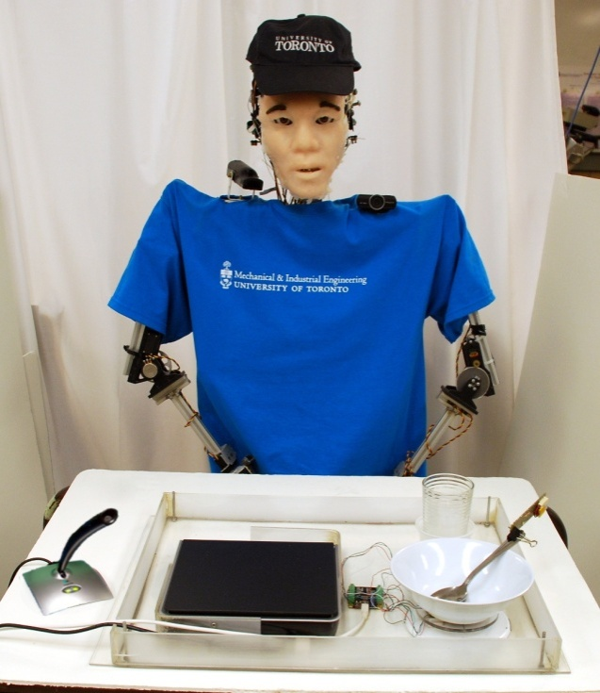

Controller
- This is the main controller.
- Folder: Controller

Program Organization
- Main4.cpp, Main4.h: This is where I’ve set up the MAXQ algorithm for the task decomposition. There is a MAXQ algorithm set up for each subtask (i.e. MAXQ_____) and also functions (i.e. Q_____) that update the Q-values.
- Controller4.cpp, Controller4.h: This is where all the primitive actions are defined. Robot control, text-to-speech, data acquisition from other modules, state updating is performed here. There are also some functions here that were used in simulation (i.e. AgentUpdate)

Important Files
- Controller\Logs: this is where the states, robot actions, training info, and meal info is stored. Meal info can be changed depending on meal and person. Training info should be deleted if it is a new online training session.
- Controller\Results: This is where the Q-values are stored. Plotter2.m will plot important Q-values in Matlab.
- Qtable.txt: this is the Q-table that is imported at the beginning of the interaction. Replace it if you updated Q-values (e.g. after 1 online training session, you can take the last Qtable___.txt file from Controller\Results if you want to continue on with the training)
- Qtable1000000.txt: the Q-values after offline training. You can replace Qtable.txt if you want to use the default values from offline training (i.e. not affected by online training)

User State Detection
- Folders: Autosmiley, Facetracker

Required Software
- OpenCV
- SplitCam (http://download.cnet.com/SplitCam/3000-2348_4-10500269.html)

Autosmiley
- We did not develop this. Downloaded from http://fffff.at/auto-smiley/. I added some communication functionality to it (i.e. so it can send info to main program), but I just left everything as is.

Facetracker
- Face detection and orientation detection was created by Kevin Choi (kchoix@hotmail.com)
- I added detectEyebrow() to detect the eyebrow.

Utensil Tracking (adib.saad@utoronto.ca)
- Folder: Facetracker

Software Required
- OpenCV
- Wiiuse library (http://sourceforge.net/projects/wiiuse/)
- Bluetooth dongle software (in this case, ASUS Bluetooth Suite)

Calibration
The Wiimote and the webcam have different viewpoints and hence there needs to be a calibration method to relate the vantage points seen by both cameras. This is achieved by finding a reference point that is common to both devices and calculating physical distance from all data that follows with respect to that point. This is done by doing the following:
- Place Wiimote, webcam and dining table in the anticipated position of operation.
- Point the Wiimote and Webcam such that the bottom-left corner of each frame is at a common point (usually the corner of the tray). This will be the reference point. This requires a live view of both cameras on a screen. For the Wiimote, use the lights shown above to find the corner of the tray.
- While sitting in the chair, find the point in space that corresponds to the left edge of the frame seen by the webcam and mark it down somehow or just use the corner of the tray (a view of the webcam on a screen is needed).
- Find the point that corresponds to the right edge of the frame and measure the distance between the two points.
- Get the number of pixels of the width of the frame and divide it by the distance. This will give you the ratio of x-pixels (pixels in the x-direction) per centimetre.
- Repeat the process for y-direction pixels and repeat the whole process again for the Wiimote. In order to do that, use the infrared lights shown above to find the desired points in space, as only they are visible on the frame.
- Note: the four ratios are not constant as one moves away from/closer to the webcam. This is why one must perform the calibration whilst seated in the chair where the patron is going to eat.
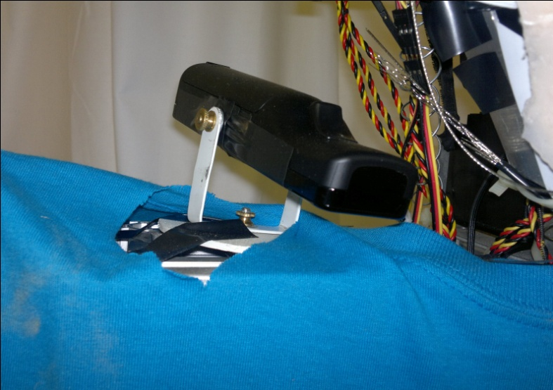
The Wiimote has a custom-built holder that allows it to rotate 360º and tilt within a limited range.
Once the four required ratios are calculated (WIIMOTE-X-PIXELS/CM, WIIMOTE-Y-PIXELS/CM. WEBCAM-X-PIXELS/CM, WEBCAM-Y-PIXELS/CM), physical distance can be related to pixel information. This is possible since the face-tracking algorithm calculates the coordinates of the face and the Wiimote find the coordinates of the spoon. Using the ratios, the distance between each object and the reference point is calculated. Then we subtract the distances between each object and the reference point to find the distance between the face and the spoon.

Troubleshooting
If the program says that the Wiiremote is not found, you may need to re-establish the Bluetooth connection with the Wiiremote.
- Open Bluetooth Devices.
- Add a device.
- Tap the 1 and 2 buttons on the Wii remote until the device is found. If the lights on the Wiiremote are not flashing when you do this, you need to replace the batteries. Should come up as “Nintendo”.
- Choose the option where you don’t need a pairing code to connect.
- If it worked, the device should show up in Device Manager on the computer.

Meal Tray (amy.do@utoronto.ca)
- Folder: sensor_mealtray

Change Empty Dishware Weights
- Empty dishware weights are located: sensor_mealtray > Debug > Plate_Weights.txt. There are multiple repeat entries but all of them have to be there and you need to change all of them. The order is: Main Dish, Side dish, Cup. If you change the dishes then you have to changes these. Also, calibration for micro load cells must be done with the new weights.

Calibration Steps for the Mirco Load Cells (0.78 g):
- Click on the Phidget Control Panel on the taskbar
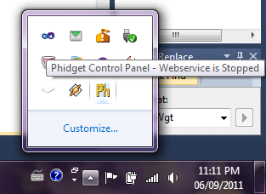
- A new window called Phidget Control Panel will appear. If the Phidget Bridge is correctly connected to the computer it will appear in the device list with as a PhidgetBridge ‘4-input’ device. For information on the calibration program, the manual for the Phidget Bridge 4-input device can at the Phidgets website: (http://www.phidgets.com/documentation/Phidgets/1046.pdf)
- Look at page 7 of the manual for information on obtaining the Y = MX+ B calibration function. Each load cell needs to be calibrated individually with a Gain of 32 selected. It is recommended to run the calibration 7-11 times for each sensor and then picking the median slope formula of the trials. (Page 7 of the manual is included on the last page of this document.)
- Load cells 0 and 1 are for the cup. The weight of the cup currently being used is 174 g. Load cells 2 and 3 are for the side dish. The weight of the side dish currently being used is 130 g.
- When the Y=MX+B formula for each load cell is obtained, open the ThesisCode project located in:
sensor_mealtray > Debug > Amy_Brian_Code
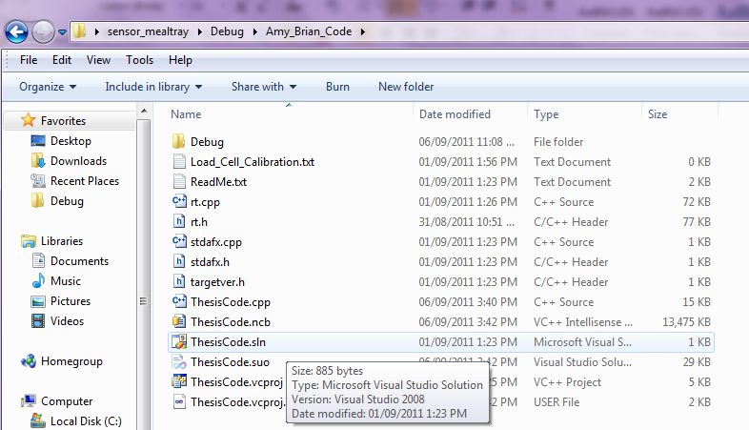
- Enter the M values and B values for each load cells into the constant static variables in ThesisCode.cpp, lines 79 and 80:
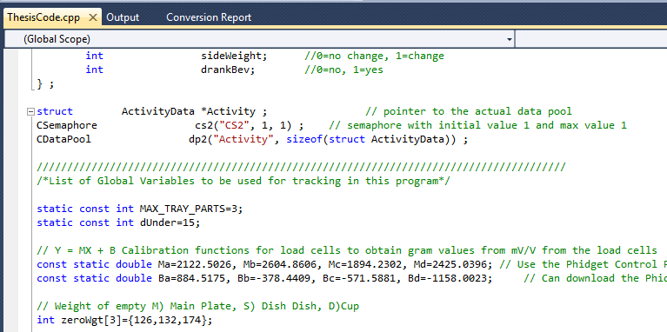
M = slope, B = offset
a=load cell 0, b=load cell 1, c=load cell2, d=load cell 3
- Compile the ThesisCode.exe program (press F7).
- Page 7 of the PhidgetBrigde 4-Input Manual:
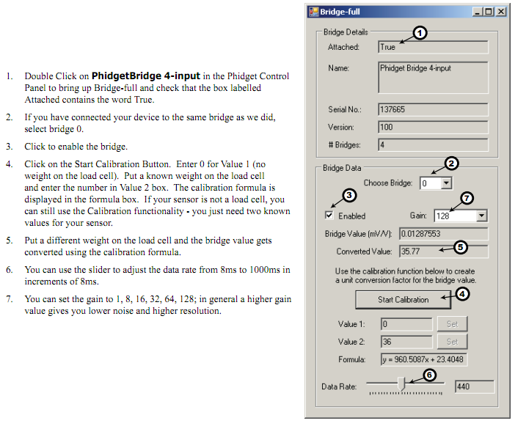

Memory Game

To Run:
- Most programs that need to be run are located in the shortcuts folder except for the Heart-rate monitor.
  - Robot-MAXQ
  - runJulius
  - Speech Analysis
  - temp (card detection)
- The emWave.sln has to be run on Visual Studio which is located in: Heart_rate\emWave

Hardware
- Brian: Facial expressions, pointing gesture, jaw  - Microphone (headset)  - Speakers  - Logitech Webcam  - Heart-rate monitor  - *Nemesysco USB Key (purple)  *Only if you’re using voice intonation | 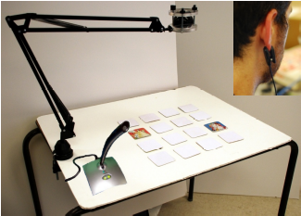

Robot-MAXQ
- This is the main controller.
- Folder: Robot-MAXQ final

Program Organization
- Main6.cpp: This is where I’ve set up the MAXQ algorithm for the task decomposition. There is a MAXQ algorithm set up for each subtask (i.e. MAXQ_____) and also functions (i.e. Q_____) that update the Q-values.
- Environment3.cpp, Envirionment3.h: This is where all the primitive actions are defined. Robot control, text-to-speech, data acquisition from other modules, state updating is performed here. There are also some functions here that were used in simulation (i.e. AgentUpdate, UpdateSpeech, HumanActCalc)

Important Files
- Qtable.txt: this is the Q-table that is imported at the beginning of the interaction. Replace it if you updated Q-values (e.g. after 1 online training session, you can take the last Qtable___.txt file from Robot-MAXQ final\results if you want to continue on with the training)
- Qtable500000.txt: the Q-values after offline training. You can replace Qtable.txt if you want to use the default values from offline training (i.e. not affected by online training)
- LevelofDiff.txt: Log of how this variable changes during HRI
- AffectiveState.txt: Log of human and robot affective state
- AffectVar.txt: log of how much training has been done so far. If you replace the Qtable.txt with the original offline training file, all the values in this file will reset.
- ActionLog.txt: Log of robot actions
- Robot-MAXQ final\results: this is where all the Q-values are stored. The plotter2.m file in this folder will plot the important Q-values in Matlab

Colour-based Method for Card Detection
- Folder: Card Detection

Required software
- Microsoft .NET Framework SDK v2.0 (http://www.microsoft.com/downloads/details.aspx?FamilyID=fe6f2099-b7b4-4f47-a244 c96d69c35dec&displaylang=en)
- Logitech Webcam Drivers
- OpenCV library (http://sourceforge.net/projects/opencvlibrary/)
- Gnu Scientific Library (GSL) (http://gnuwin32.sourceforge.net/packages/gsl.htm)
Note: Don’t install the Logitech webcam software if you are using a Windows 7 computer. It does not work properly on Win7 computers. Instead use webcam software to view the video feed and adjust settings. I have the Philips one installed on the laptop. It’s called “Webcam Video Viewer”.

Changing Colour Ranges
In the function card_data Findcard(), you can change the colour ranges by changing the max and min values.

Heart-rate Monitoring

Required Software
- EmWave desktop
- extraPutty (http://www.extraputty.com/)

Troubleshooting
If your program is not updating with the current heart-rate, the putty configuration might be wrong.
- Open putty.exe at C:\Program Files\ExtraPuTTY\Bin
- Click “emwave”. Click Load.
- Click on Session->Logging.
- Check where the log file is saved. Change if necessary. It should be saved as putty.txt in this folder: Heart_rate\emWave
- Click on Session. Click on “emwave”. Click save.

SIFT-based Method for Card Detection
Folder: SIFT vision system

Execution
match.exe in SIFT vision system\emailsift\match\Debug

Important Folders
- SIFT vision system\emailsift\match\MEM data: this is where the card database is located
- SIFT vision system\emailsift\match\results: results are here

Voice Intonation
Folders:
- nmsVoiceAnalysisRun
- nmsVoiceAnalysisRunCPP
- nmsVoiceAnalysisLibrary

Required Software
- Nemesysco QA5 Win32 SDK

Important Files
- nmsVoiceAnalysisRunCpp/VoiceAnalysisResults.txt: output values for all emotion parameters
- nmsVoiceAnalysisRunCpp/HumanEmo.txt: used for updating human affect in main controller
- nmsVoiceAnalysisRunCpp/RobotEmo.txt: used for updating robot emotion in main controller (this model is based on Junichi’s work)

Bijan’s Notes (bijan.shahriari@utoronto.ca)
Nemesysco Voice Analysis Program (QA5 Trainer) --- C# and Visual Basic
- Description: This is Nemesysco's sample program that analyzes a wave file for emotional parameters of a given voice. This can be found on the original CD provided by Nemesysco, and is called “QA5 Trainer”. I have a few versions of the program on my computer, but they are modified and probably won't work, so don't use them.
- Make Sure: That the small purple USB key is in the computer and lit red when you are using the program. This is used for verification of authenticity by Nemesysco, and their programs will not run without it. Also, make sure you have all necessary drivers installed (these can be found on the CD).
Nemesysco Voice Analysis Program (Bijan's version) --- C# Library, but runs in C++
- Before you Start: Download and install the .NET SDK from the following website. Even if you already have it installed, just run “repair” on the installation. http://www.microsoft.com/downloads/details.aspx?FamilyID=fe6f2099-b7b4-4f47-a244-c96d69c35dec&displaylang=en
- Description: This is my version of Nemesysco's program, which is meant to run in real-time. Currently, it gets a human voice as input, records emotional parameters associated with each sentence of speech, and calculates the corresponding emotional parameter of the robot. The program is written in C#, but is called in C++, to make it easier to integrate with other programs. This is actually a complicated thing to do, and so I will try to explain how I did this, just in case you, the reader, need to know. If you don't need to know, and just want to know how to alter the program and run it, skip ahead of the Detailed Description section. But remember, having knowledge of this can't hurt, and will definitely be useful in some situations when your program won't run because of reasons unrelated to your coding.
- Detailed Description: The first (and most important) thing you need to know is how to create a C# Class Library and call it using a C++ Console Application (i.e., an application with a “main” function, if you have little programming experience). Read the following tutorial, follow it step by step, and understand it. Don't be discouraged by the “requirements” Microsoft lists to be able to understand it, I didn't meet them and I understood it fine. http://support.microsoft.com/kb/828736
- Now, normally this knowledge would be enough to run a C# DLL in C++. However, Nemesysco happens to have its own C# DLL (Interop.QA5COM.dll), which has to be called by the C# DLL I made. Just as my DLL has to be strong named with an .snk file, so do all third-party DLLs (such as Nemesysco's) that my program calls. Unfortunately, we don't have access to Nemesyco's code to directly to change the DLL and make it strong named. I followed the steps listed by “nimit” in the following forum post to make Interop.QA5COM.dll strong named (using the same .snk file I used above). http://social.msdn.microsoft.com/forums/en-US/clr/thread/35930958-9775-4e56-bd38-0362d124ffc4/
- Fortunately, you don't have to make that DLL strong named, because I already did. But just in case the strong named version of the DLL goes missing, or a similar situation arises in the future, I included the last step.
Quick Guide to changing the code, and running the program:
- Open nmsVoiceAnalysisLibrary.sln in Microsoft Visual Studio 2008. For some reason, the program does not work properly in 2010 version. Change whatever code you need to in nmsFunctions.cs, and press Build using 'Release' mode.
- Open the .NET SDK command prompt from Start → Microsoft .NET Framework SDK 2.0 → SDK Command Prompt. Navigate to the folder that contains your .dll file by entering “cd C:\Documents and Settings\user\Desktop\Bijan's Work\nmsVoiceAnalysisLibrary\bin\Release” without quotes in the command prompt.
- Type “regasm nmsVoiceAnalysisLibrary.dll /tlb:nmsVoiceAnalysisLibrary.tlb /codebase” without quotes in the command prompt.
- Open nmsVoiceAnalysisRunCPP.sln. Run the program.
- Results are written as follows in the nmsVoiceAnalysisRunCPP folder:
- VoiceAnalysisResults.txt --- overall results throughout the program’s run time.
- HumanEmo.txt --- 1 = angry, 2 = sad, 3 = neutral, 4 = happy (updated after each sentence spoken. A sentence is defined as a voice spoken between two periods of silence).
- RobotEmo.txt --- 1 = happy, 2= neutral, 3 = sad, 4 = angry (updated after the human emotions are updated) [yes, the numbers are in the opposite order as the human emotions]
Understanding my code:
- First off, it would be useful to read Nemesysco’s user manual, and run their sample program “QA5 Trainer.” These can be found on Nemesysco’s CD. Again, don’t use the QA5 Trainer programs in the Bijan’s Work folder on my computer, since I have modified them.
- The main chunk of the code can be found in nmsFunctions.cs in nmsVoiceAnalysisLibrary.sln. I have basically broken things up into two main functions: Initialize, and Start.
- public bool Initialize()
  - Initializes the Nemesysco Core and anything you need to run their programs. Returns true if successful. If it returns false (you can check this in the C++ program), make sure the verification USB is plugged in.
- public void Start()
  - The functions here are implemented from Ianier Munoz’s code “A full-duplex audio player in C# using the waveIn/waveOut APIs” which can be found on its own here: http://www.codeproject.com/KB/audio-video/cswavrec.aspx
This code basically allows for real-time playback of sound streaming through a microphone to your speakers using the audio buffer in the computer’s sound card.
  - m_Recorder is the line of code that records the voice streaming through the microphone and performs all of Nemesysco’s analysis. The m_Player line of code just plays back what you are saying through the speakers, and can be commented out if you wish. I generally like to keep it uncommented for debugging purposes, and then comment it out for implementation.
    - m_Recorder uses the BufferDoneEventHandler DataArrived, which is just a “private void” function you can find in the code. Within this function, there are two main functions of interest: MiniRead, and ProcessBuffer2. MiniRead just reads the buffer information, m_RecBuffer (in bytes), into a short integer array inpBuf. inpBuf is then passed to the function ProcessBuffer2, which performs analysis. Here, I write all relevant information to text files to be read by Billy’s MAXQ program. I also write some text files that are useful for debugging and long-term analysis.
    - The “silenceCount” parameter in ProcessBuffer2 is used to detect sentences. So when the program detects two instances of “silence” in the buffer, then it recognizes that as a sentence, and proceeds to calculate Human and Robot emotions.
    - private void FindRobotDominant(int HumanEmotion) calculates a Robot emotion based on the corresponding Human emotion using a state equation with matrices A and B2. The equations used are simple ones, that assume that A and B2 are not changing. However, you may wish to implement a more robust program that “trains” A and B2 online. The numbers for A and B2 were determined through offline training.
    - Important Note: “countNum” is the variable that dictates how long the program will run for. Right now, I have it set as the maximum number an integer can be, but you can reduce it to a much smaller number (i.e., 10-20) if you want to do quick tests for debugging. This is because the file containing total voice analysis results, VoiceAnalysisResults.txt, will not update until the end of the program. You can figure out when the program is finished by uncommenting m_Player, and waiting until your voice doesn’t transmit to the speakers anymore. Also, note that other text files such as HumanEmo.txt and RobotEmo.txt don’t require you to wait until the program is done to update (because they are continuously opened and closed in the program, not just kept open until the end).
    - A final note: I have some lines of code commented out in my program. Other than m_Player which I addressed above, the rest of the commented code can pretty much be disregarded, as they were not useful for running my program.

If your program stops running for no reason...:
...and you haven't changed any code from the last time it ran or you don't have any clue why it isn't running, do three things first:
- Make sure you have installed the Nemesysco and verification USB drivers on the computer you are using (found on the Nemesysco CD).
- Make sure you have the verification USB plugged in.
- Re-install .NET SDK (run repair in the installation). This actually ended up fixing my problems a few times. I think the problem was Windows Updates messing up .NET, so just re-install this, reboot your computer, and see if the program runs.
Running the C# code in C#:
You should also know that you can run the C# in C# (not C++) by running the nmsVoiceAnalysisRun.sln file (read: NOT nmsVoiceAnalysisRunCPP.sln) in Bijan’s Work\nmsVoiceAnalysisRun folder. However, running the code in C++ is obviously better if you want to integrate it with other C++ code.

